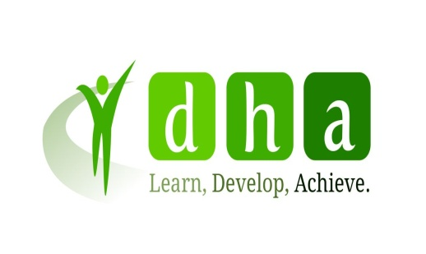
Equality & Diversity Policy

Equality & Diversity Statement

Dh Associates is committed to providing high quality learning and assessment to all our potential customers. All subcontractors must comply with this policy.

Dh Associates will promote equal of opportunity to all learners, including commercial and funded learners such as apprentices, and potential learners and will ensure effective equality and diversity by all employees of the company.

Dh Associates will ensure that all learners are treated with respect to their individuality. Any special assessment needs will be identified and resources and assessment adapted to take account of individual needs.

Dh Associates will work with contracting organisations to anticipate and plan to take account of the individual needs of their learners.

Dh Associates will ensure that no discrimination occurs during any of its internal procedures and processes. All employees have been trained and are aware of the policy and its implications for practice.

Dh Associates will comply with the equal opportunities requirements of QCA, the Code of Practice and awarding bodies.

Implementing Equality & Diversity
Promotion
Dh Associates will promote the training and qualifications it offers ensuring access to underrepresented groups. We offer 24 hour access to learning ensuring learning reaches part time, shift and night staff.

Entrance Requirements
Learners will be able to access training and qualifications based on their identified needs. We will identify any barriers to learning with contractors and work with them to reduce these.

Enrolment and Registration
The registration form enables the early collection of equal opportunities information. For learners, the employer and DH Associates this enables identification of any need to adapt resources or the programme.

Induction
All learners receive a thorough induction and have access to DH Associates handbook explaining our commitment to equal opportunities and their rights as a learner. We explain at induction the support that is available to them from Dh Associates and how to proceed if a complaint arises. All learners complete an initial skill scan and self evaluation to identify any learning or special assessment needs. We also discuss the actions we would take if a learner discriminated or experienced discrimination within their work place.

Programme
During the delivery of programmes equal opportunities are promoted with learners through role modeling and enabling learners to reflect on equal opportunities in their daily practice. At 3 months we review all learners’ progress looking at any issues regarding access to assessment and agreeing solutions.

We have and will continue to adapt assessment practice and resources to take account of special assessment needs. We will engage interpreters to ensure access to Deaf candidates, ensure access to adapted materials for candidates with visual impairments, provide alternative assessment methods to those with English as a second language.

Assessment
Assessment will be based on the requirements of the qualifications. Learners will be assured equal access to fair assessment and have the right to appeal assessment decisions. The appeal procedure is explained at induction. The internal quality assurance arrangements will actively monitor fair assessment will not be influenced by gender, race, age, disability or any other factor.
Reasonable adjustments will be made to meet special assessment needs provided this does not compromise the integrity of qualifications and advice will be sought if necessary from awarding bodies through the external verifier.

Facilities
To ensure equal access to assessment all meetings will take place at the learners workplace.

Complaints Procedures
There is a complaints procedure for learners and this is explained to all learners at induction. Learners can complain if they experience discrimination or sexual or racial harassment or bullying.

Staff Development
All employees have had training on equal opportunities. Updates are incorporated into personal development plans. Specific training is provided on equal opportunities eg Deaf Awareness.

Monitoring
All information on equal opportunities, progress and achievement is entered on DH Associates database to enable monitoring and comparisons to be made. Reports on individuals and groups of learners are sent to employers on a monthly basis to enable issues affecting progress to be identified and addressed.

Action Plan
The Director of Quality & Compliance is responsible ensuring the implementation and monitoring of equal opportunities and diversity through procedures and processes for managing contracts, learners and employees.

Equality Action Plan November 2020

Area for Improvement | Success criteria | Milestone | Person Responsible | Review
Promote learning opportunities that are accessible to all | Learner cohort for 2020/21 reflects catchment population of sector | Promote accessible learning to all Employers and Learners  Ensure diversity is reflected in marketing materials | DHA Employment Engagement Staff & Delivery Staff
Maintain/improve achievement and retention across different groups of learners based on equality indicators | Achievement and retention rates show only minor variance across different groups of learners based on equality indicators | Ensure delivery of learning matches individual needs and learning styles  Provide resources to support learners with different learning nee  Monitor retention and achievement rates making recommendations based on findings | DHA Managers & Trainers  DHA Managers & Trainer  DHA Director of Quality & Compliance
Promote open and transparent culture and approach with learners and employers | Employers and learners value service and score highly in satisfaction and evaluation surveys | Communication and relationships with learners and employers are based on clear contracts and agreements  Concerns, Comments and complaints from learners and employers are used to learn and improve the service  Comments and complaints from learners and employers are dealt with at first stage with satisfactory resolution | DHA Employer Engagement staff, Managers & Trainers  DHA Director of Quality & Compliance  DHA Employer Engagement staff ,Managers & Assessors

